UNITED STATES
SECURITIES AND EXCHANGE COMMISSION
Washington, D.C. 20549

Form 6-K

REPORT OF FOREIGN PRIVATE ISSUER
PURSUANT TO RULE 13a-16 OR 15d-16
UNDER THE SECURITIES EXCHANGE ACT OF 1934

For the month of July 2026

Commission File Number: 001-42523

GCL Global Holdings Ltd
(Exact Name of Registrant as Specified in its Charter)

29 Tai Seng Avenue, #02-01
Singapore 534119
(Address of Principal Executive Offices and Zip Code)

Registrant’s telephone number, including area code: +65 80427330

Indicate by check mark whether the registrant files or will file annual reports under cover of Form 20-F or Form 40-F.

Form 20-F ☒ Form 40-F ☐

On July 31, 2026, GCL Global Holdings Ltd. (“GCL”) issued a press release announcing its financial results for the fiscal year ended March 31, 2026, a copy of which is being furnished as Exhibit 99.1 hereto. As previously announced, GCL hosted a conference call to discuss its fiscal year 2026 results on Friday, July 31, 2026, at 8:00 a.m. EDT. An investors deck related to the conference call is being furnished as Exhibit 99.2 hereto.

Exhibits

99.1 |  | Press release dated July 31, 2026 announcing financial results for the fiscal year ended March 31, 2026.
99.2 |  | GCL Fiscal Year 2026 Earnings Presentation.

1

SIGNATURE

Pursuant to the requirements of the Securities Exchange Act of 1934, the registrant has duly caused this report to be signed on its behalf by the undersigned, hereunto duly authorized.

Dated: July 31, 2026 | GCL Global Holdings Ltd.
 | By: | /s/ Sebastian Toke
 | Name: | Sebastian Toke
 | Title: | Group CEO

2

Exhibit 99.1

GCL Announces Fiscal Year 2026 Financial Results

SINGAPORE– July 31, 2026 – GCL Global Holdings Ltd. (NASDAQ: GCL) (“GCL” or the “Company”), a leading provider of games and entertainment, today announced its financial results for the year ended March 31, 2026.

FY2026 Highlights

 | ● | Revenues of $238.9 million, up 68.2% from the prior year period

 | ● | Gross Margin of 10.3% compared to 15.0% in fiscal year 2025

 | ● | Net loss of $26.2 million, compared to net income of $5.0 million in the same period last year

 | ● | EBITDA loss of $18.9 million, compared to a gain of $10.8 million in fiscal year 2025.

“Fiscal 2026 marked a transformational year for GCL as we significantly expanded the breadth and strategic capabilities of our business, while delivering strong revenue growth,” said Sebastian Toke, Group CEO for GCL. “We continued our transition from a predominately distribution-led model toward a more diversified, higher-value platform combining publishing, proprietary content and scalable distribution capabilities. These investments have positioned the Company with broader capabilities, deeper market reach and a stronger foundation to serve customers more effectively in the global gaming market.

“While the investments made in publishing and IP development and the investment required to integrate and operate a substantially larger platform weighed on profitability during the year, we believe the strategic progress achieved in fiscal 2026 will allow us to return to profitability and create meaningful opportunities ahead. We are committed to increasing the contribution from higher-margin publishing and proprietary content, realizing integration efficiencies, maintaining disciplined working capital management, and steadily reducing leverage. We believe these initiatives will translate our expanded scale and growing publishing pipeline into long-term value for our shareholders.”

Revenues for fiscal year 2026 increased by 68.2% to US$238.9 million, compared with US$142.1 million in the prior year, reflecting the expansion of the Company’s operating platform, including the contribution from the Ban Leong business and continued activities across its gaming distribution and publishing operations.

Gross profit increased 16.4% year over year to $24.7 million for the year ended March 31, 2026. Gross margin decreased to 10.3% from 15.0% over the same period, primarily due to a higher contribution from higher-volume, lower-margin distribution activities within the Company’s expanded revenue base.

Selling and marketing expenses were $4.8 million for FY 2026 compared to $2.6 million in the prior year period, principally reflecting the larger scale of the Company’s operations and increased support for distribution and publishing activities. As a percentage of revenue, selling and marketing expenses remained broadly stable at approximately 2.0%.

General and administrative expense increased to $33.2 million for FY 2026 compared to $15.4 million in the same period last year, reflecting the consolidation and operation of a significantly larger Company, additional personnel and professional costs, integration activities and the Company’s operation for the first full fiscal year as a Nasdaq-listed company.

Net interest expense increased to US$3.0 million for the current period, reflecting higher borrowings associated with the Company’s acquisition activities and working capital requirements.

Net loss was $26.2 million for fiscal 2026, compared to net income of $5.0 million in the prior year period. The year-on-year movement also reflected the non-recurrence of a $5.3 million noncash fair value gain recorded in FY 2025 in relation to an investment in convertible notes. Loss per share, basic and diluted, was $0.20 for FY 2026, compared to a gain of $0.05 per share for the same period last year. While fiscal 2026 saw a loss making year for the group, overturning a profit from the year before, this was largely due to almost $20 million in one-off exceptional expenses such as professional fees linked to the acquisition of BLT and non-operational losses stemming from a change in fair value of derivative liabilities within the group.

EBITDA for fiscal year 2026 was a loss of US$18.9 million, compared with EBITDA of US$10.8 million in the prior fiscal year. However, EBITDA loss excluding a non-operational loss of USS$11.7 million on fair value on derivative liabilities and US$6.7 million of one-off expenses, is at US$0.5 million.

Balance Sheet

As of March 31, 2026, the Company had $36.6 million in cash and cash equivalents, compared to $18.2 million a year earlier. The Company reported positive working capital of approximately $42.9 million.

Inventory increased to $32.4 million from $5.9 million in the year ago period, primarily reflecting the expansion of the Company’s physical and games distribution activities and the working capital requirements of a larger business.

Total bank borrowings were approximately $54.0 million as of March 31, 2026, of which $32.3 million was classified as noncurrent and $21.7 million as current. The increase principally supported acquisition activities and the operating requirements of the expanded Company.

Outlook

Management expects the larger operating platform to support continued business scale in FY 2027. The Company will focus on improving its revenue mix, increasing contributions from higher-margin activities, enhancing operating efficiencies and improving on cash conversion.

The timing and financial contribution of individual game releases may vary depending on game development and launch schedules, and market conditions.

Key FY 2026 and Subsequent Developments

 | ● | On September 4, 2025, GCL and subsidiary 4Divinity Pte. Ltd. (“4Divinity”) announced the launch of “Mandragora: Whispers of the Witch Tree” on PlayStation®5 and Nintendo Switch in Asia.

 | ● | On September 5, 2025, GCL announced that it had entered into a global publishing agreement for the upcoming highly anticipated First-person shooter game “The Defiant.”

 | ● | On September 11, 2025, 4Divinity signed a memorandum of understanding to acquire a 60% equity stake in Taiwan’s Alliance-Star International via a strategic share swap.

 | ● | On March 31, 2026, GCL announced that 4Divinity had entered a multi-million, multi-year agreement with Syngrid Technology HK Limited, an international strategic infrastructure engine for esports ecosystem development and pan-entertainment content.

2

 | ● | On April 14, 2026, GCL announced that 4Divinity entered an Asia-wide (excluding Japan) agreement with the developer of “Windrose” to lead the marketing, publishing, and distribution of game activation codes across the region for the highly anticipated pirate survival adventure game.

 | ● | On May 19, 2026, GCL announced that ADATA Technology, a global leader in memory and storage solutions listed on the Taipei Exchange, invested an additional $10 million into 4Divinity, following ADATA’s initial investments of $3.0 million announced in December 2025 and $10.0 million announced in January 2026.

 | ● | On May 26, 2026, GCL announced that 4Divinity, together with Leap Studio, officially launched “Realm of Ink,” the highly anticipated, fast-paced action roguelite in its full v1.0 release for PC and consoles.

 | ● | On June 18, 2026, GCL announced that 4Divinity had secured worldwide publishing and distribution rights for the upcoming action-stealth RPG “A Whisper of Fall: Jinyiwei” from Chengdu Cangmo Information Technology Co., Ltd.

 | ● | On June 30, 2026, GCL announced that 4Divnity had secured exclusive worldwide publishing and distribution rights from developer Eschatology Entertainment for its upcoming debut game, “Guns of Eschaton.”

Conference Call

The earnings release and related investor deck will be available prior to the event in the “Financial Results” section under “Financials”, while the live webcast will be available on the investor relations homepage and in the “Events” section under the “News & Events” header on the investor relations website at ir.gclglobalholdings.com.

For participants who wish to dial in to the conference, please register in advance using the link provided below and dial in 10 to 15 minutes prior to the call. Dial-in numbers, passcode and unique access PIN would be provided upon registering.

Dial-in registration link

A webcast replay of the call will be available at ir.gclglobalholdings.com for one year following the call.

About GCL Global Holdings

GCL Global Holdings Ltd. (“GCL”) is a holding company incorporated in the Cayman Islands (GCL together with its subsidiaries, the “GCL Group”). Through its operating subsidiaries, GCL Group unites people through its ecosystem of content and hardware in games and entertainment, enabling creators to deliver engaging experiences to gaming communities worldwide with a strategic focus on the rapidly expanding Asian gaming market.

Drawing on a deep understanding of gaming trends and market dynamics, GCL Group leverages its diverse portfolio of digital and physical content as well as multimedia peripherals to bridge cultures and reach a global audience by introducing Asian-developed IP across consoles and PCs.

Learn more at http://www.gclglobalholdings.com.

3

Forward-Looking Statements

This press release includes “forward-looking statements” made under the “safe harbor” provisions of the U.S. Private Securities Litigation Reform Act of 1995, and may be identified by the use of words such as “estimate,” “plan,” “project,” “forecast,” “intend,” “will,” “expect,” “anticipate,” “believe,” “seek,” “target” or other similar expressions that predict or indicate future events or trends or that are not statements of historical matters. These forward-looking statements may also include, but are not limited to, statements regarding projections, estimates and forecasts of revenue and other financial and performance metrics, projections of market opportunity and expectations, the estimated implied enterprise value of GCL, GCL’s ability to scale and grow its business, the advantages and expected growth of GCL, and GCL’s ability to source and retain creative talent and publish games. These statements are based on various assumptions, whether or not identified in this press release, and on the current expectations of GCL’s management, and are not predictions of actual performance.

These statements involve risks, uncertainties, and other factors that may cause actual results, levels of activity, performance, or achievements to be materially different from those expressed or implied by these forward-looking statements. Although GCL believes that it has a reasonable basis for each forward-looking statement contained in this press release, GCL cautions you that these statements are based on a combination of facts and factors currently known and projections of the future, which are inherently uncertain. In addition, there are risks and uncertainties described in GCL’s annual report on Form 20-F, filed with the SEC on July 31, 2026, and other documents filed by GCL from time to time with the SEC. These filings may identify and address other important risks and uncertainties that could cause actual events and results to differ materially from those contained in the forward-looking statements. GCL cannot assure you that the forward-looking statements in this press release will prove to be accurate. There may be additional risks that GCL presently knows or that GCL currently believes are immaterial that could also cause actual results to differ from those contained in the forward-looking statements. In light of the significant uncertainties in these forward-looking statements, nothing in this press release should be regarded as a representation by any person that the forward-looking statements set forth herein will be achieved or that any of the contemplated results of such forward-looking statements will be achieved. The forward-looking statements in this press release represent the views of GCL as of the date of this press release. Subsequent events and developments may cause those views to change. However, while GCL may update these forward-looking statements in the future, there is no current intention to do so, except to the extent required by applicable law. You should, therefore, not rely on these forward-looking statements as representing the views of GCL as of any date subsequent to the date of this press release. Except as may be required by law, GCL does not undertake any duty to update these forward-looking statements.

Non-GAAP Measures

Some of the financial information and data contained in this press release, such as EBITDA, have not been prepared in accordance with U.S. generally accepted accounting principles (“GAAP”). GCL believes these non-GAAP measures of financial results provide useful information to management and investors regarding certain financial and business trends relating to GCL’s financial condition and results of operations. GCL’s management uses these non-GAAP measures for trend analysis and for budgeting and planning purposes. GCL believes that the use of these non-GAAP measures provides an additional tool for investors to evaluate projected operating results and trends, as well as compare GCL’s financial measures with those of other similar companies, many of which also present similar non-GAAP financial measures to investors.

Management of GCL does not consider these non-GAAP measures in isolation or as an alternative to financial measures determined in accordance with GAAP. The principal limitation of these non-GAAP financial measures is that they exclude significant expenses and income that are required by GAAP to be recorded in GCL’s financial statements. In addition, they are subject to inherent limitations as they reflect the exercise of judgments by management about which expenses and income are excluded or included in determining these non-GAAP financial measures. You should review GCL’s audited financial statements, which are presented in the most recent annual report on Form 20-F filed with the SEC on July 31, 2026, and not rely on any single financial measure to evaluate GCL’s business.

GCL Investor Relations:

Crocker Coulson
Crocker.coulson@aumadvisors.com
(646) 652-7185

4

GCL GLOBAL HOLDINGS LTD AND ITS SUBSIDIARIES
CONSOLIDATED BALANCE SHEETS
(Stated in U.S. dollar, except for the number of shares)

 |  | March 31 |  |  |  | March 31
 |  | 2026 |  |  |  | 2025
ASSETS
CURRENT ASSETS
Cash and cash equivalents |  | $ | 36,577,264 |  |  | $ | 18,247,380
Restricted cash |  |  | 2,741,404 |  |  |  | 3,131,335
Accounts receivable, net |  |  | 36,654,784 |  |  |  | 25,761,683
Amount due from related parties |  |  | 164,292 |  |  |  | 392,334
Inventories, net |  |  | 32,416,453 |  |  |  | 5,936,223
Other receivable and other current assets, net |  |  | 2,654,096 |  |  |  | 1,733,022
Prepayments, net |  |  | 13,868,916 |  |  |  | 6,239,861
Loan to third party |  |  | 678,204 |  |  |  | 382,024
Derivative asset |  |  | 326,766 |  |  |  | 269,119
Total current assets |  |  | 126,082,179 |  |  |  | 62,092,981
NONCURRENT ASSETS
Property and equipment, net |  |  | 1,624,600 |  |  |  | 380,315
Definite-lived intangible assets, net |  |  | 6,146,890 |  |  |  | 2,207,852
Indefinite-lived intangible assets |  |  | 10,051,143 |  |  |  | 14,324,323
Goodwill |  |  | 12,351,587 |  |  |  | 2,990,394
Long-term investments |  |  | 16,841,899 |  |  |  | 15,435,274
Prepayments, a related party |  |  | 5,000,000 |  |  |  | 3,000,000
Operating leases right-of-use assets |  |  | 3,416,686 |  |  |  | 442,376
Finance leases right-of-use assets |  |  | 668,822 |  |  |  | 363,008
Deferred tax assets, net |  |  | 997,954 |  |  |  | 351,060
Total noncurrent assets |  |  | 57,099,581 |  |  |  | 39,494,602
TOTAL ASSETS |  | $ | 183,181,760 |  |  | $ | 101,587,583
LIABILITIES, AND SHAREHOLDERS’ EQUITY
CURRENT LIABILITIES
Bank loans, current |  | $ | 21,715,464 |  |  | $ | 10,500,085
Convertible notes, net of unamortized discounts of $20,979 and $0 as of March 31, 2026 and 2025 |  |  | 1,207,022 |  |  |  | -
Accounts payable |  |  | 32,825,509 |  |  |  | 28,389,357
Accounts payable, a related party |  |  | 4,293,316 |  |  |  | 4,567,337
Contract liabilities |  |  | 8,179,636 |  |  |  | 505,323
Other payables and accrued liabilities |  |  | 9,972,124 |  |  |  | 4,702,791
Operating lease liabilities, current |  |  | 1,663,734 |  |  |  | 376,751
Contingent consideration for acquisition, current |  |  | - |  |  |  | 1,121,006
Finance leases liabilities, current |  |  | 112,687 |  |  |  | 84,528
Amount due to related parties |  |  | 1,042,949 |  |  |  | 683,338
Derivative liabilities |  |  | 495,000 |  |  |  | -
Tax payables |  |  | 1,624,995 |  |  |  | 1,417,173
Total current liabilities |  |  | 83,132,436 |  |  |  | 52,347,689
NON-CURRENT LIABILITIES
Operating lease liabilities, non-current |  |  | 1,790,741 |  |  |  | 110,368
Finance leases liabilities, non-current |  |  | 294,648 |  |  |  | 164,606
Bank loans, non-current |  |  | 32,265,166 |  |  |  | 1,421,139
Deferred investment consideration payable |  |  | 7,500,000 |  |  |  | 7,500,000
Derivative liabilities, non-current |  |  | 16,206,000 |  |  |  | 3,086,519
Deferred tax liabilities |  |  | 1,097,163 |  |  |  | -
Total non-current liabilities |  |  | 59,153,718 |  |  |  | 12,282,632
TOTAL LIABILITIES |  |  | 142,286,154 |  |  |  | 64,630,321
COMMITMENTS AND CONTINGENCIES
SHAREHOLDERS’ EQUITY
Ordinary share, par value $0.0001; 500,000,000 shares authorized,130,135,432 and 126,276,372 shares issued as of March 31, 2026 and 2025, respectively, and 128,008,703 and 121,947,978 outstanding as of March 31, 2026 and 2025, respectively |  |  | 12,803 |  |  |  | 12,196
Additional paid-in capital |  |  | 44,213,702 |  |  |  | 18,149,582
(Accumulated deficit) retained earnings |  |  | (7,481,845 | ) |  |  | 17,513,985
Accumulated other comprehensive income |  |  | 52,676 |  |  |  | 178,312
TOTAL GCL Global Holdings Ltd shareholders’ equity |  |  | 36,797,336 |  |  |  | 35,854,075
Non-controlling interests |  |  | 4,098,270 |  |  |  | 1,103,187
TOTAL SHAREHOLDERS’ EQUITY |  |  | 40,895,606 |  |  |  | 36,957,262
TOTAL LIABILITIES, AND SHAREHOLDERS’ EQUITY |  | $ | 183,181,760 |  |  | $ | 101,587,583

5

GCL GLOBAL HOLDINGS LTD AND ITS SUBSIDIARIES
CONSOLIDATED STATEMENTS OF OPERATIONS AND COMPREHENSIVE (INCOME) LOSS
(Stated in U.S. dollar, except for the number of shares)

 |  | For the Years Ended March 31,
 |  | 2026 |  |  |  | 2025 |  |  |  | 2024
REVENUES
Revenues |  | $ | 238,805,340 |  |  | $ | 140,563,181 |  |  | $ | 97,492,224
Revenues, a related party |  |  | 118,749 |  |  |  | 1,509,405 |  |  |  | 42,477
TOTAL REVENUES |  |  | 238,924,089 |  |  |  | 142,072,586 |  |  |  | 97,534,701
COST OF REVENUES
Cost of revenues |  |  | (202,693,150 | ) |  |  | (104,995,460 | ) |  |  | (65,970,028 | )
Cost of revenues, related parties |  |  | (11,502,810 | ) |  |  | (15,833,765 | ) |  |  | (18,246,215 | )
TOTAL COST OF REVENUES |  |  | (214,195,960 | ) |  |  | (120,829,225 | ) |  |  | (84,216,243 | )
GROSS PROFIT |  |  | 24,728,129 |  |  |  | 21,243,361 |  |  |  | 13,318,458
OPERATING EXPENSES
Selling and marketing |  |  | (4,848,605 | ) |  |  | (2,568,702 | ) |  |  | (2,602,892 | )
General and administrative |  |  | (33,151,801 | ) |  |  | (15,438,447 | ) |  |  | (13,109,638 | )
TOTAL OPERATING EXPENSES |  |  | (38,000,406 | ) |  |  | (18,007,149 | ) |  |  | (15,712,530 | )
(LOSS) INCOME FROM OPERATIONS |  |  | (13,272,277 | ) |  |  | 3,236,212 |  |  |  | (2,394,072 | )
OTHER INCOME (EXPENSE)
Other income, net |  |  | 2,151,369 |  |  |  | 867,823 |  |  |  | 1,266,239
Interest expense, net |  |  | (3,039,054 | ) |  |  | (2,255,934 | ) |  |  | (507,803 | )
Change in fair value of contingent consideration for acquisition |  |  | (19,438 | ) |  |  | (545,428 | ) |  |  | (272,029 | )
Change in fair value of investment in convertible notes |  |  | (1,188,928 | ) |  |  | 5,254,103 |  |  |  | -
Change in fair value of derivative asset and derivative liabilities |  |  | (10,595,140 | ) |  |  | (378,683 | ) |  |  | -
TOTAL OTHER (EXPENSE) INCOME, NET |  |  | (12,691,191 | ) |  |  | 2,941,881 |  |  |  | 486,407
(LOSS) INCOME BEFORE INCOME TAXES |  |  | (25,963,468 | ) |  |  | 6,178,093 |  |  |  | (1,907,665 | )
INCOME TAXES EXPENSE |  |  | (239,753 | ) |  |  | (1,128,672 | ) |  |  | (53,291 | )
NET (LOSS) INCOME |  |  | (26,203,221 | ) |  |  | 5,049,421 |  |  |  | (1,960,956 | )
Less: net loss attributable to non-controlling interests |  |  | (1,207,391 | ) |  |  | (538,204 | ) |  |  | (587,452 | )
NET (LOSS) INCOME ATTRIBUTABLE TO GCL GLOBAL HOLDINGS LTD’S SHAREHOLDERS |  | $ | (24,995,830 | ) |  | $ | 5,587,625 |  |  | $ | (1,373,504 | )
NET (LOSS) INCOME |  |  | (26,203,221 | ) |  |  | 5,049,421 |  |  |  | (1,960,956 | )
OTHER COMPREHENSIVE (LOSS) INCOME
Foreign currency translation adjustments |  |  | (12,652 | ) |  |  | 312,217 |  |  |  | (87,881 | )
COMPREHENSIVE (LOSS) INCOME |  |  | (26,215,873 | ) |  |  | 5,361,638 |  |  |  | (2,048,837 | )
Less: total comprehensive loss attributable to non-controlling interests |  |  | (1,257,069 | ) |  |  | (522,820 | ) |  |  | (583,642 | )
Total comprehensive (loss) income attributable to GCL Global Holdings Ltd’s shareholders |  | $ | (24,958,804 | ) |  | $ | 5,884,458 |  |  | $ | (1,465,195 | )
(LOSS) EARNING PER SHARE - BASIC AND DILUTED, ORDINARY SHARES |  | $ | (0.20 | ) |  | $ | 0.05 |  |  | $ | (0.01 | )
WEIGHTED AVERAGE NUMBER OF ORDINARY SHARES OUTSTANDING
Basic and diluted |  |  | 123,232,562 |  |  |  | 107,184,280 | * |  |  | 105,013,283 | *

* | Giving retroactive effect to reverse recapitalization effected on February 13, 2025.

6

 |  | For the years ended March 31,
 |  | 2026 |  |  |  | 2025 |  |  |  | 2024
 |  | US$ |  |  |  | US$ |  |  |  | US$
Net (loss) / income |  |  | (26,203,221 | ) |  |  | 5,049,421 |  |  |  | (1,960,956 | )
Interest expense, net |  |  | 3,039,054 |  |  |  | 2,255,934 |  |  |  | 507,803
Provision for income taxes |  |  | 239,753 |  |  |  | 1,128,672 |  |  |  | 53,291
Depreciation and amortization expenses |  |  | 4,018,456 |  |  |  | 2,369,036 |  |  |  | 2,371,718
EBITDA |  |  | (18,905,958 | ) |  |  | 10,803,063 |  |  |  | 971,856

7

Exhibit 99.2

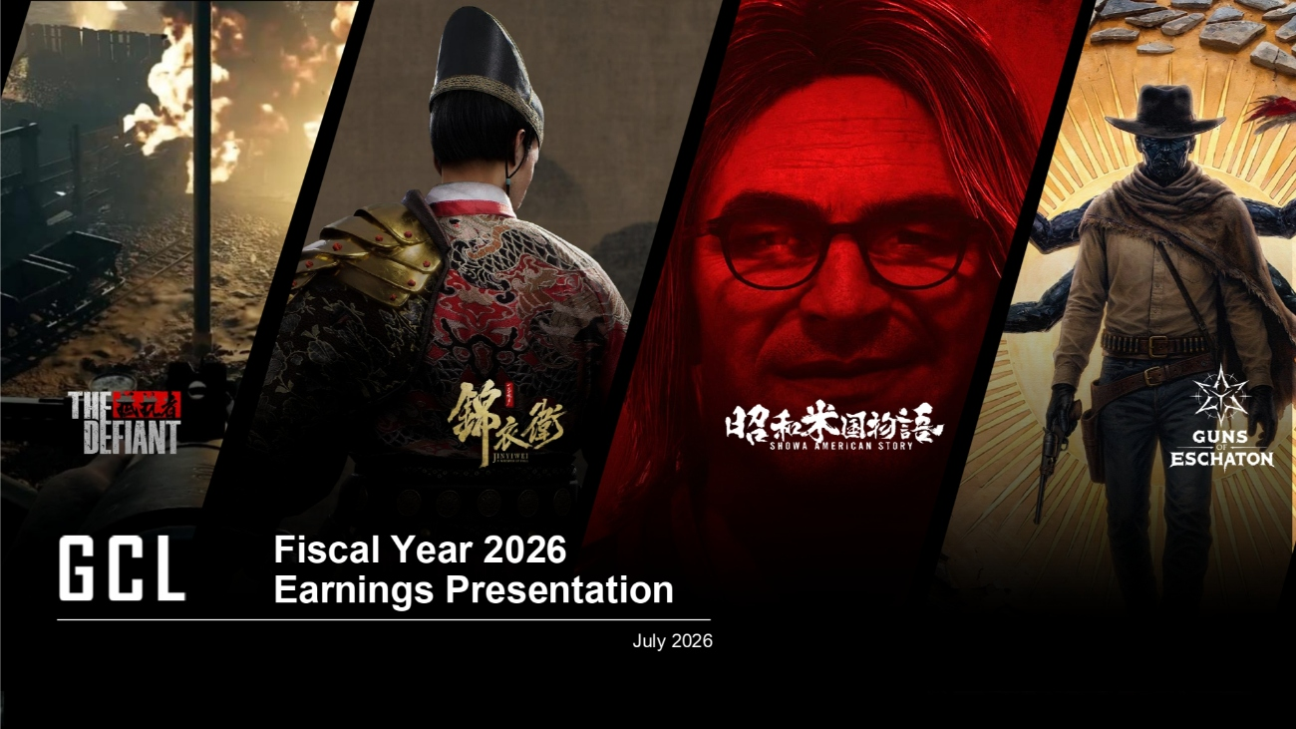
THE ASIAN POWERHOUSE IN GAMES & ENTERTAINMENT 1 Fiscal Year 2026 Earnings Presentation July 2026

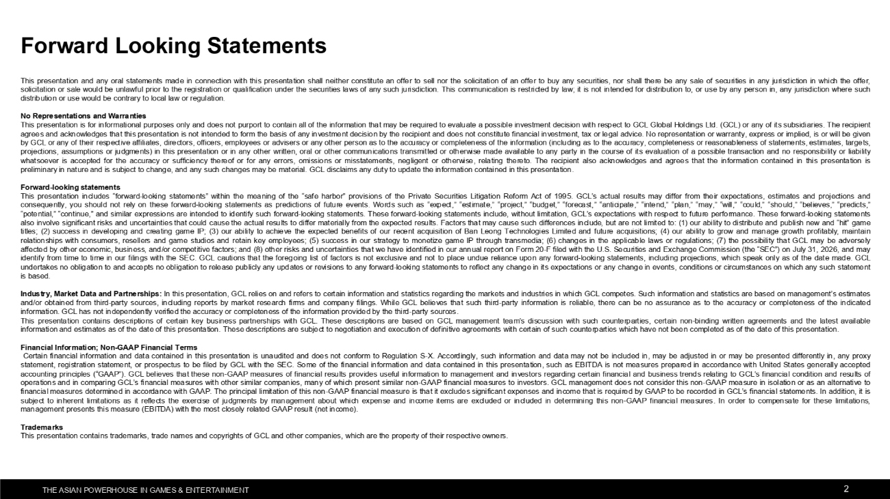
THE ASIAN POWERHOUSE IN GAMES & ENTERTAINMENT 2 This presentation and any oral statements made in connection with this presentation shall neither constitute an offer to sell nor the solicitation of an offer to buy any securities, nor shall there be any sale of securities in any jurisdiction in which the offer, solicitation or sale would be unlawful prior to the registration or qualification under the securities laws of any such jurisdiction. This communication is restricted by law; it is not intended for distribution to, or use by any person in, any jurisdiction where such distribution or use would be contrary to local law or regulation. No Representations and Warranties This presentation is for informational purposes only and does not purport to contain all of the information that may be required to evaluate a possible investment decision with respect to GCL Global Holdings Ltd. (GCL) or any of its subsidiaries. The recipient agrees and acknowledges that this presentation is not intended to form the basis of any investment decision by the recipient and does not constitute financial investment, tax or legal advice. No representation or warranty, express or implied, is or will be given by GCL or any of their respective affiliates, directors, officers, employees or advisers or any other person as to the accuracy or completeness of the information (including as to the accuracy, completeness or reasonableness of statements, estimates, targets, projections, assumptions or judgments) in this presentation or in any other written, oral or other communications transmitted or otherwise made available to any party in the course of its evaluation of a possible transaction and no responsibility or liability whatsoever is accepted for the accuracy or sufficiency thereof or for any errors, omissions or misstatements, negligent or otherwise, relating thereto. The recipient also acknowledges and agrees that the information contained in this presentation is preliminary in nature and is subject to change, and any such changes may be material. GCL disclaims any duty to update the information contained in this presentation. Forward-looking statements This presentation includes "forward-looking statements" within the meaning of the "safe harbor" provisions of the Private Securities Litigation Reform Act of 1995. GCL's actual results may differ from their expectations, estimates and projections and consequently, you should not rely on these forward-looking statements as predictions of future events. Words such as "expect," "estimate," "project," "budget," "forecast," "anticipate," "intend," "plan," "may," "will," "could," "should," "believes," "predicts," "potential," "continue," and similar expressions are intended to identify such forward-looking statements. These forward-looking statements include, without limitation, GCL's expectations with respect to future performance. These forward-looking statements also involve significant risks and uncertainties that could cause the actual results to differ materially from the expected results. Factors that may cause such differences include, but are not limited to: (1) our ability to distribute and publish new and "hit" game titles; (2) success in developing and creating game IP; (3) our ability to achieve the expected benefits of our recent acquisition of Ban Leong Technologies Limited and future acquisitions; (4) our ability to grow and manage growth profitably, maintain relationships with consumers, resellers and game studios and retain key employees; (5) success in our strategy to monetize game IP through transmedia; (6) changes in the applicable laws or regulations; (7) the possibility that GCL may be adversely affected by other economic, business, and/or competitive factors; and (8) other risks and uncertainties that we have identified in our annual report on Form 20-F filed with the U.S. Securities and Exchange Commission (the "SEC") on July 31, 2026, and may identify from time to time in our filings with the SEC. GCL cautions that the foregoing list of factors is not exclusive and not to place undue reliance upon any forward-looking statements, including projections, which speak only as of the date made. GCL undertakes no obligation to and accepts no obligation to release publicly any updates or revisions to any forward-looking statements to reflect any change in its expectations or any change in events, conditions or circumstances on which any such statement is based. Industry, Market Data and Partnerships: In this presentation, GCL relies on and refers to certain information and statistics regarding the markets and industries in which GCL competes. Such information and statistics are based on management's estimates and/or obtained from third-party sources, including reports by market research firms and company filings. While GCL believes that such third-party information is reliable, there can be no assurance as to the accuracy or completeness of the indicated information. GCL has not independently verified the accuracy or completeness of the information provided by the third-party sources. This presentation contains descriptions of certain key business partnerships with GCL. These descriptions are based on GCL management team's discussion with such counterparties, certain non-binding written agreements and the latest available information and estimates as of the date of this presentation. These descriptions are subject to negotiation and execution of definitive agreements with certain of such counterparties which have not been completed as of the date of this presentation. Financial Information; Non-GAAP Financial Terms Certain financial information and data contained in this presentation is unaudited and does not conform to Regulation S-X. Accordingly, such information and data may not be included in, may be adjusted in or may be presented differently in, any proxy statement, registration statement, or prospectus to be filed by GCL with the SEC. Some of the financial information and data contained in this presentation, such as EBITDA is not measures prepared in accordance with United States generally accepted accounting principles ("GAAP"). GCL believes that these non-GAAP measures of financial results provides useful information to management and investors regarding certain financial and business trends relating to GCL's financial condition and results of operations and in comparing GCL's financial measures with other similar companies, many of which present similar non-GAAP financial measures to investors. GCL management does not consider this non-GAAP measure in isolation or as an alternative to financial measures determined in accordance with GAAP. The principal limitation of this non-GAAP financial measure is that it excludes significant expenses and income that is required by GAAP to be recorded in GCL's financial statements. In addition, it is subject to inherent limitations as it reflects the exercise of judgments by management about which expense and income items are excluded or included in determining this non-GAAP financial measures. In order to compensate for these limitations, management presents this measure (EBITDA) with the most closely related GAAP result (net income). Trademarks This presentation contains trademarks, trade names and copyrights of GCL and other companies, which are the property of their respective owners. Forward Looking Statements

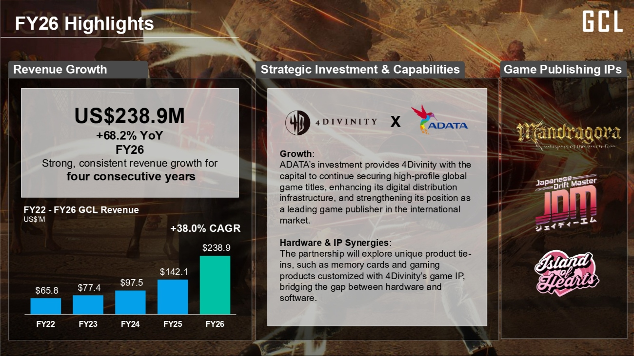
THE ASIAN POWERHOUSE IN GAMES & ENTERTAINMENT 3 FY26 Highlights Revenue Growth Strategic Investment & Capabilities Game Publishing IPs X FY22 - FY26 GCL Revenue US$'M Growth: ADATA's investment provides 4Divinity with the capital to continue securing high-profile global game titles, enhancing its digital distribution infrastructure, and strengthening its position as a leading game publisher in the international market. Hardware & IP Synergies: The partnership will explore unique product tie- ins, such as memory cards and gaming products customized with 4Divinity's game IP, bridging the gap between hardware and software. $65.8 $77.4 $97.5 $142.1 $238.9 FY22 FY23 FY24 FY25 FY26 +38.0% CAGR US$238.9M +68.2% YoY FY26 Strong, consistent revenue growth for four consecutive years


THE ASIAN POWERHOUSE IN GAMES & ENTERTAINMENT 4 Game Publishing & Distribution

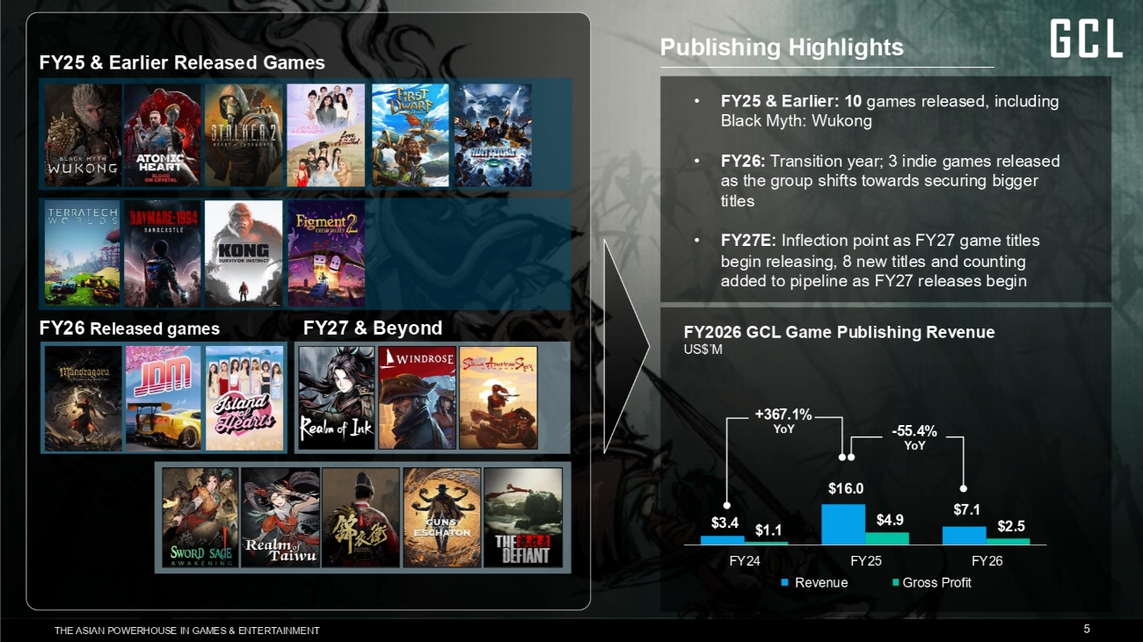
THE ASIAN POWERHOUSE IN GAMES & ENTERTAINMENT 5 Publishing Highlights • FY25 & Earlier: 10 games released, including Black Myth: Wukong • FY26: Transition year; 3 indie games released as the group shifts towards securing bigger titles • FY27E: Inflection point as FY27 game titles begin releasing, 8 new titles and counting added to pipeline as FY27 releases begin FY2026 GCL Game Publishing Revenue US$'M +367.1% YoY -55.4% YoY FY25 & Earlier Released Games FY26 Released games FY27 & Beyond $3.4 $16.0 $7.1 $1.1 $4.9 $2.5 FY24 FY25 FY26 Revenue Gross Profit

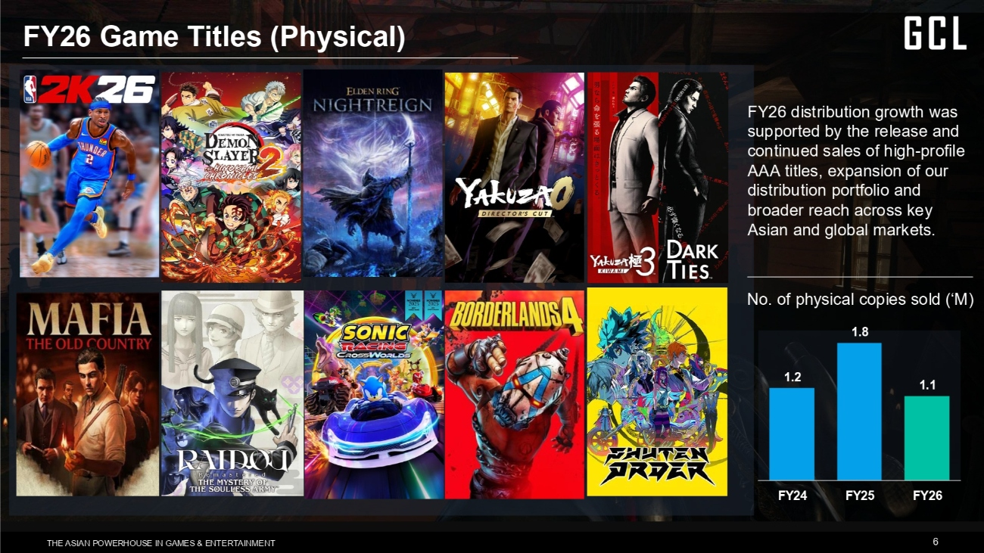
THE ASIAN POWERHOUSE IN GAMES & ENTERTAINMENT 6 FY26 Game Titles (Physical) FY26 distribution growth was supported by the release and continued sales of high-profile AAA titles, expansion of our distribution portfolio and broader reach across key Asian and global markets. 1.2 1.8 1.1 FY24 FY25 FY26 No. of physical copies sold ('M)

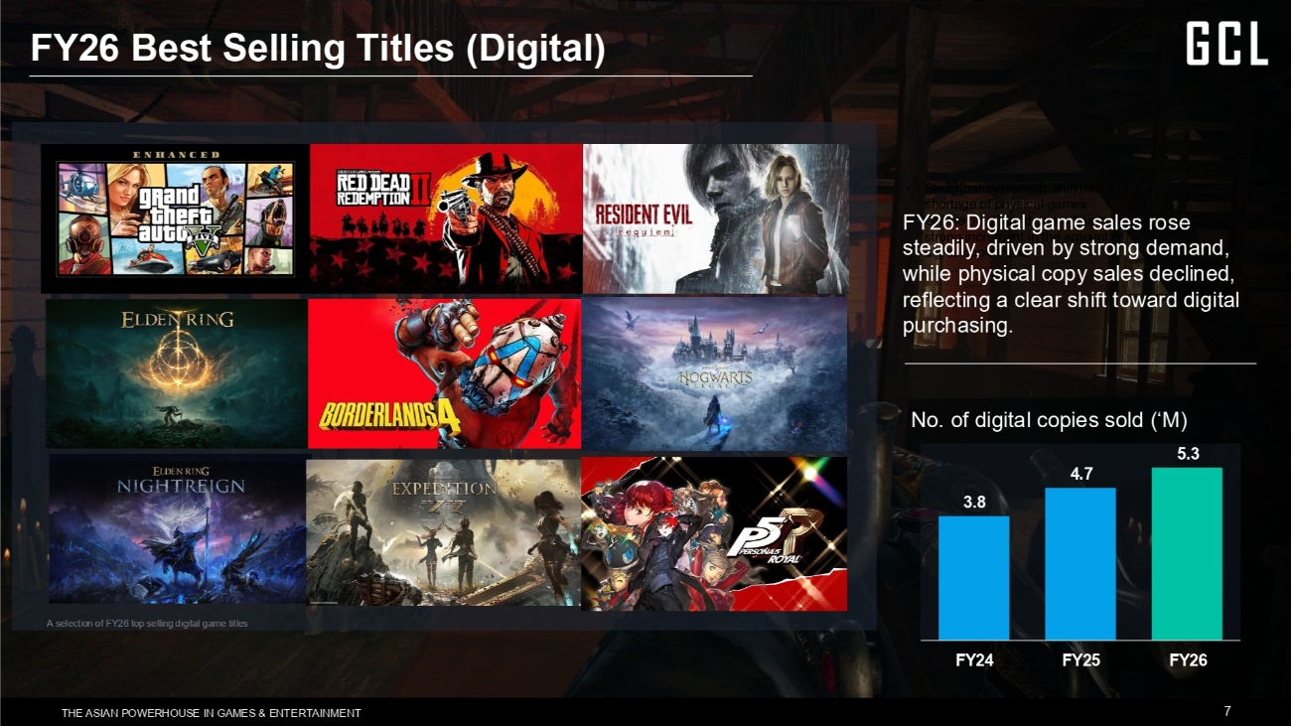
THE ASIAN POWERHOUSE IN GAMES & ENTERTAINMENT 7 FY26 Best Selling Titles (Digital) • Structural systematic shift into a shortage of physical games • On the other hand, there has been a strong increment in the amount of digital copies sold 3.8 4.7 5.3 FY24 FY25 FY26 FY26: Digital game sales rose steadily, driven by strong demand, while physical copy sales declined, reflecting a clear shift toward digital purchasing. No. of digital copies sold ('M) A selection of FY26 top selling digital game titles


THE ASIAN POWERHOUSE IN GAMES & ENTERTAINMENT 8 Game Portfolio Momentum

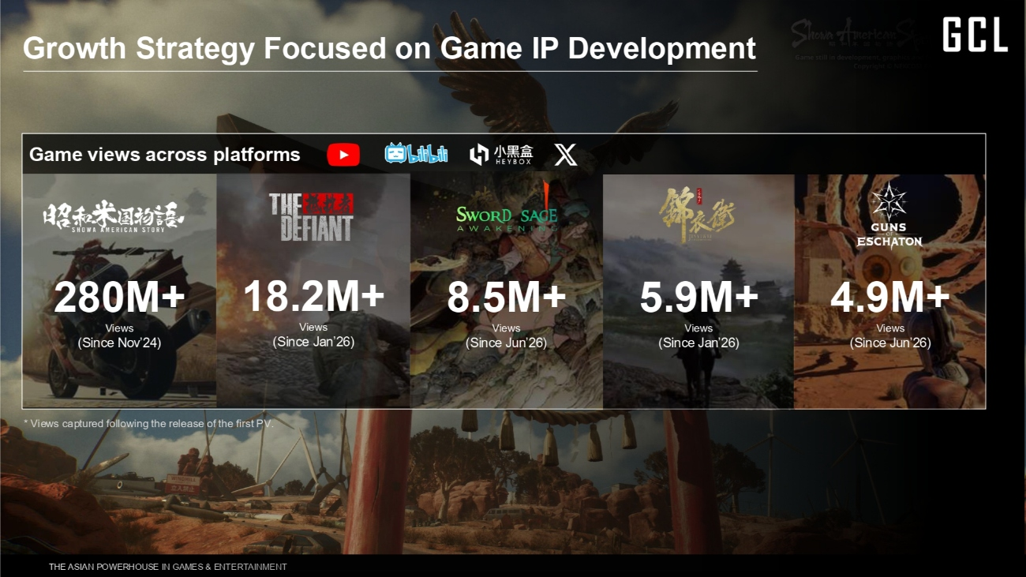
THE ASIAN POWERHOUSE IN GAMES & ENTERTAINMENT 9 Growth Strategy Focused on Game IP Development Game views across platforms 280M+ Views (Since Nov'24) 18.2M+ Views (Since Jan'26) 8.5M+ Views (Since Jun'26) 5.9M+ Views (Since Jan'26) 4.9M+ Views (Since Jun'26) * Views captured following the release of the first PV.


Showa American Story The Defiant A Whisper Of Fall: Jinyiwei A story-driven first-person shooter set against the rarely explored backdrop of the Second Sino-Japanese War, blending stealth, action, espionage, and tactical gameplay. Showa American Story is emerging as one of the most anticipated original IPs in gaming, with the potential to become a defining title of its release year. A Ming Dynasty action-stealth RPG featuring an immersive historical setting, exploration, political intrigue, and espionage https://www.youtube.com/watch?v=BIUQo1y74Fw https://www.youtube.com/watch?v=smpcIYdwtr4 https://www.youtube.com/watch?v=29rGPx5NjaE GUNS OF ESCHATON As the final work of Viktor Antonov, art director of Half- Life 2 and Dishonored, Guns of Eschaton carries the unmistakable vision of one of gaming's greatest world builders. https://www.youtube.com/watch?v=9ehTefmCsQ8

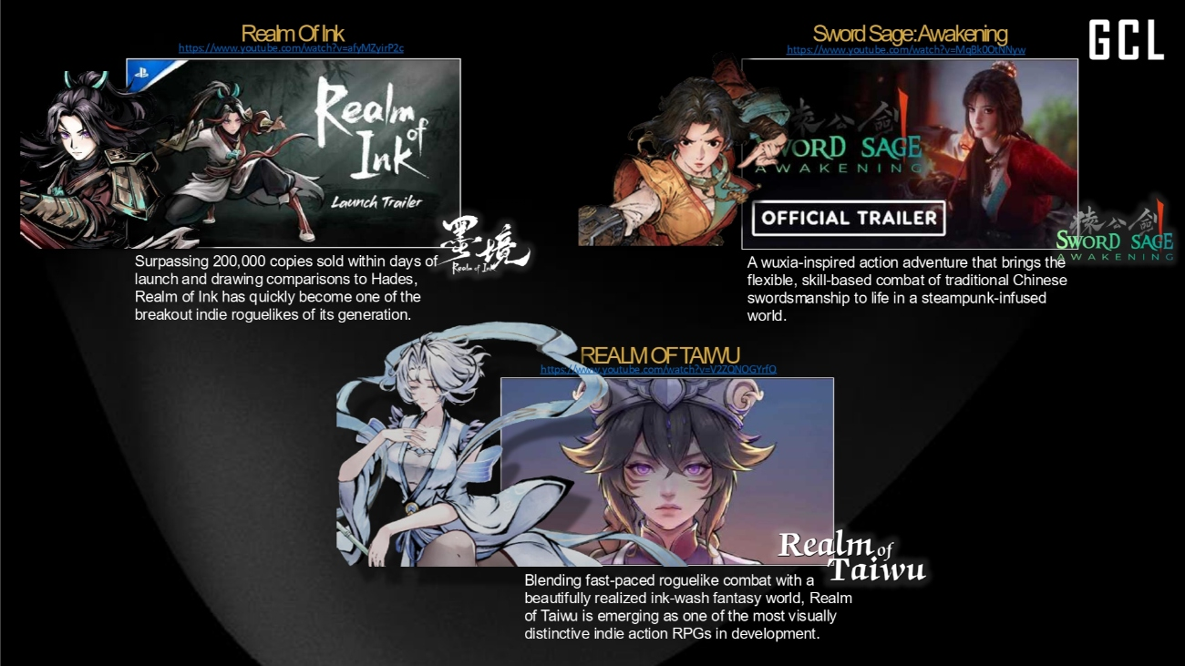
"Blending fast-paced roguelike combat with a beautifully realized ink-wash fantasy world, Realm of Taiwu is emerging as one of the most visually distinctive indie action RPGs in development." Realm Of Ink Sword Sage: Awakening REALM OF TAIWU A wuxia-inspired action adventure that brings the flexible, skill-based combat of traditional Chinese swordsmanship to life in a steampunk-infused world. Surpassing 200,000 copies sold within days of launch and drawing comparisons to Hades, Realm of Ink has quickly become one of the breakout indie roguelikes of its generation. Blending fast-paced roguelike combat with a beautifully realized ink-wash fantasy world, Realm of Taiwu is emerging as one of the most visually distinctive indie action RPGs in development. https://www.youtube.com/watch?v=afyMZyirP2c https://www.youtube.com/watch?v=V2ZQNOGYrfQ https://www.youtube.com/watch?v=MqBk0OtNNyw


THE ASIAN POWERHOUSE IN GAMES & ENTERTAINMENT 12 Financial Results

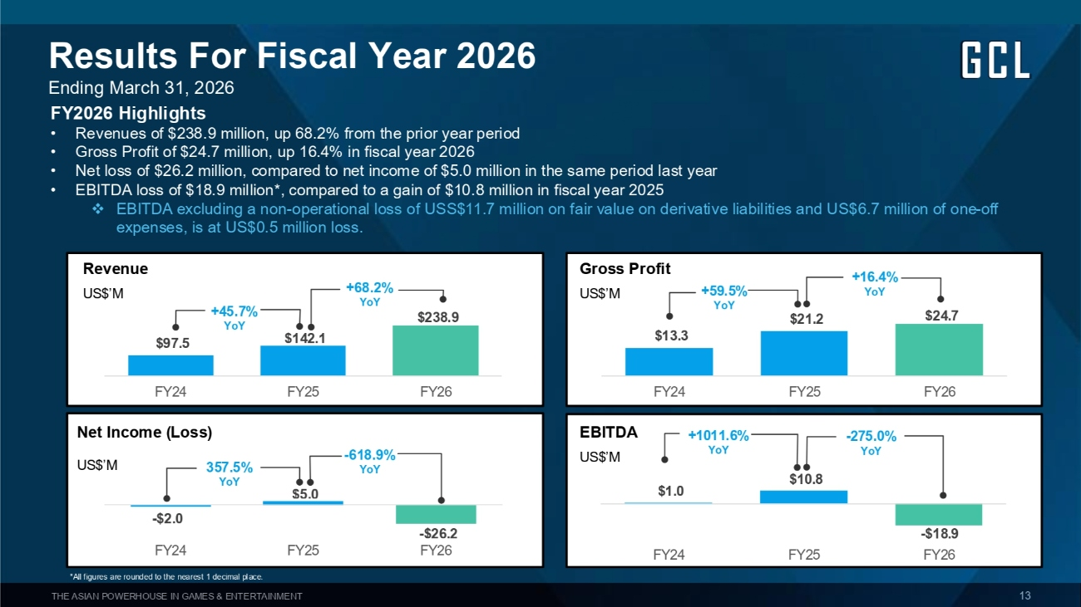
THE ASIAN POWERHOUSE IN GAMES & ENTERTAINMENT 13 Results For Fiscal Year 2026 Ending March 31, 2026 FY2026 Highlights • Revenues of $238.9 million, up 68.2% from the prior year period • Gross Profit of $24.7 million, up 16.4% in fiscal year 2026 • Net loss of $26.2 million, compared to net income of $5.0 million in the same period last year • EBITDA loss of $18.9 million*, compared to a gain of $10.8 million in fiscal year 2025 ❖EBITDA excluding a non-operational loss of USS$11.7 million on fair value on derivative liabilities and US$6.7 million of one-off expenses, is at US$0.5 million loss. Revenue US$'M $97.5 $142.1 $238.9 FY24 FY25 FY26 $13.3 $21.2 $24.7 FY24 FY25 FY26 Gross Profit US$'M +45.7% YoY +68.2% YoY +59.5% YoY +16.4% YoY Net Income (Loss) US$'M -$2.0 $5.0 -$26.2 FY24 FY25 FY26 $1.0 $10.8 -$18.9 FY24 FY25 FY26 EBITDA US$'M 357.5% YoY -618.9% YoY -275.0% YoY +1011.6% YoY *All figures are rounded to the nearest 1 decimal place.

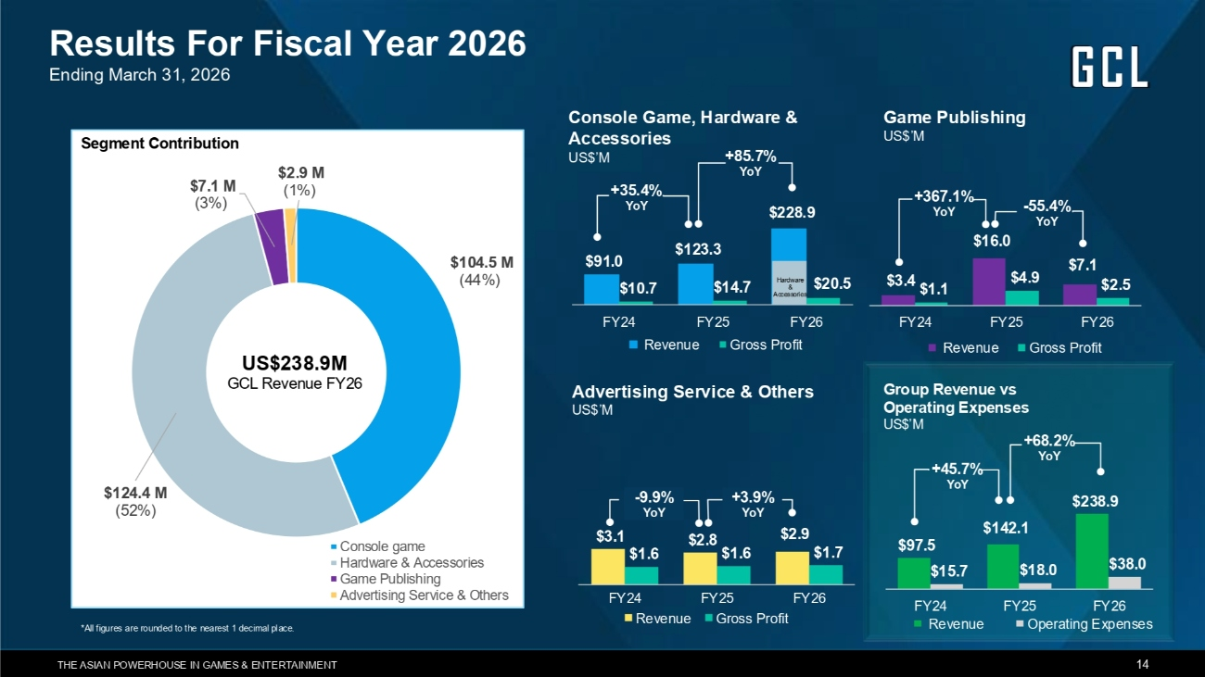
THE ASIAN POWERHOUSE IN GAMES & ENTERTAINMENT 14 $104.5 M (44%) $124.4 M (52%) $7.1 M (3%) $2.9 M (1%) Console game Hardware & Accessories Game Publishing Advertising Service & Others Segment Contribution US$238.9M GCL Revenue FY26 Console Game, Hardware & Accessories US$'M $3.1 $2.8 $2.9 $1.6 $1.6 $1.7 FY24 FY25 FY26 Revenue Gross Profit $3.4 $16.0 $7.1 $1.1 $4.9 $2.5 FY24 FY25 FY26 Revenue Gross Profit Game Publishing US$'M +367.1% YoY -55.4% YoY Advertising Service & Others US$'M -9.9% YoY +3.9% YoY $97.5 $142.1 $238.9 $15.7 $18.0 $38.0 FY24 FY25 FY26 Revenue Operating Expenses +45.7% YoY +68.2% YoY Results For Fiscal Year 2026 Ending March 31, 2026 Group Revenue vs Operating Expenses US$'M *All figures are rounded to the nearest 1 decimal place. $91.0 $123.3 $228.9 $10.7 $14.7 $20.5 FY24 FY25 FY26 Revenue Gross Profit Hardware & Accessories +85.7% YoY +35.4% YoY

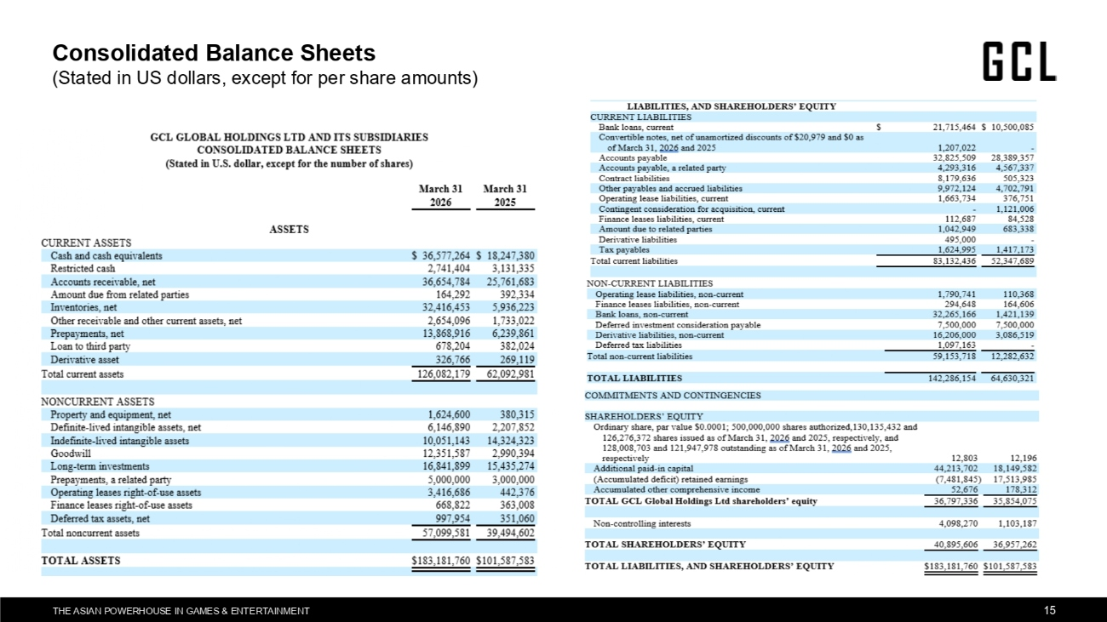
THE ASIAN POWERHOUSE IN GAMES & ENTERTAINMENT 15 Consolidated Balance Sheets (Stated in US dollars, except for per share amounts)

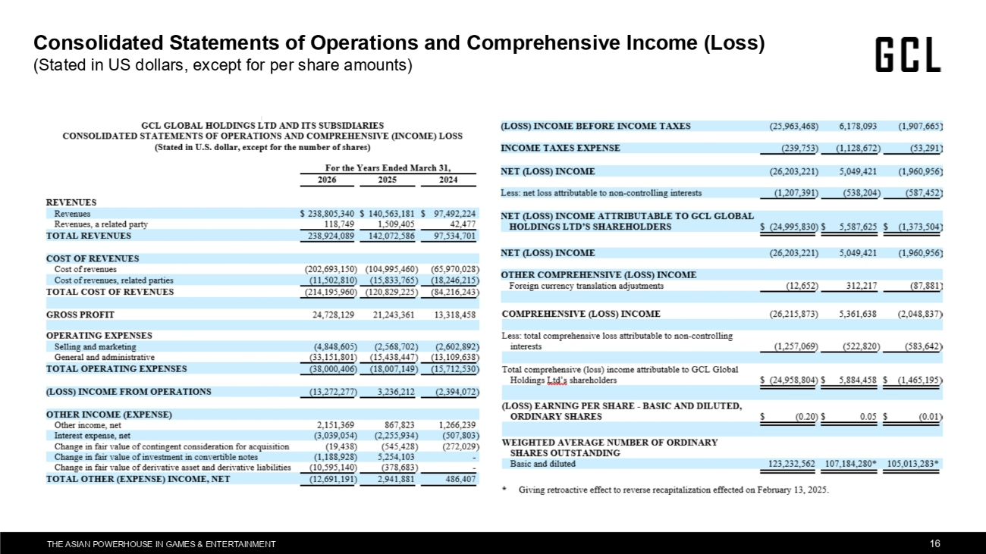
THE ASIAN POWERHOUSE IN GAMES & ENTERTAINMENT 16 Consolidated Statements of Operations and Comprehensive Income (Loss) (Stated in US dollars, except for per share amounts)

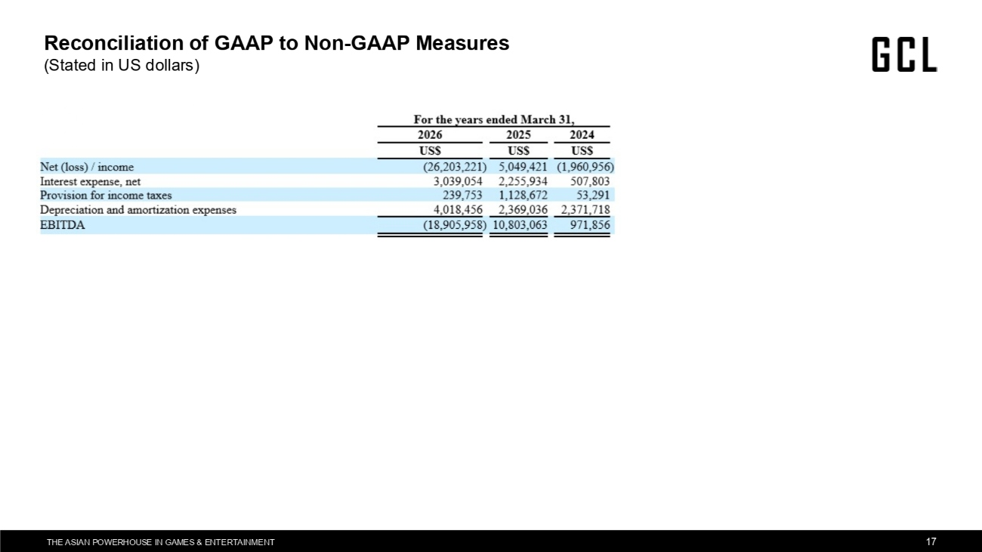
THE ASIAN POWERHOUSE IN GAMES & ENTERTAINMENT 17 Reconciliation of GAAP to Non-GAAP Measures (Stated in US dollars)

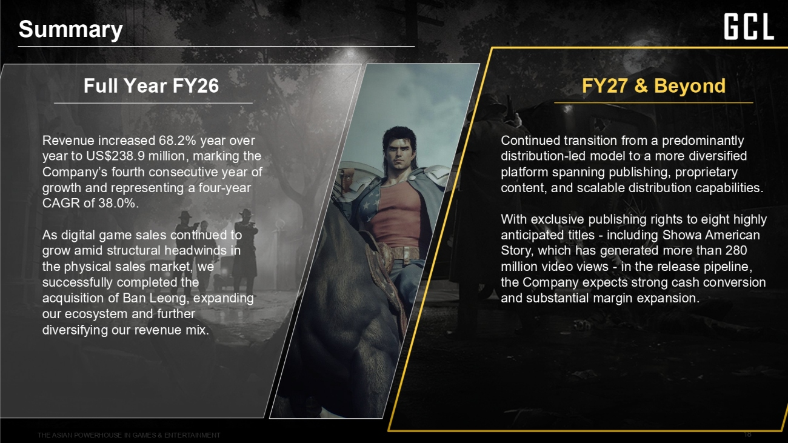
THE ASIAN POWERHOUSE IN GAMES & ENTERTAINMENT 18 Summary Full Year FY26 FY27 & Beyond Revenue increased 68.2% year over year to US$238.9 million, marking the Company's fourth consecutive year of growth and representing a four-year CAGR of 38.0%. As digital game sales continued to grow amid structural headwinds in the physical sales market, we successfully completed the acquisition of Ban Leong, expanding our ecosystem and further diversifying our revenue mix. Continued transition from a predominantly distribution-led model to a more diversified platform spanning publishing, proprietary content, and scalable distribution capabilities. With exclusive publishing rights to eight highly anticipated titles - including Showa American Story, which has generated more than 280 million video views - in the release pipeline, the Company expects strong cash conversion and substantial margin expansion.

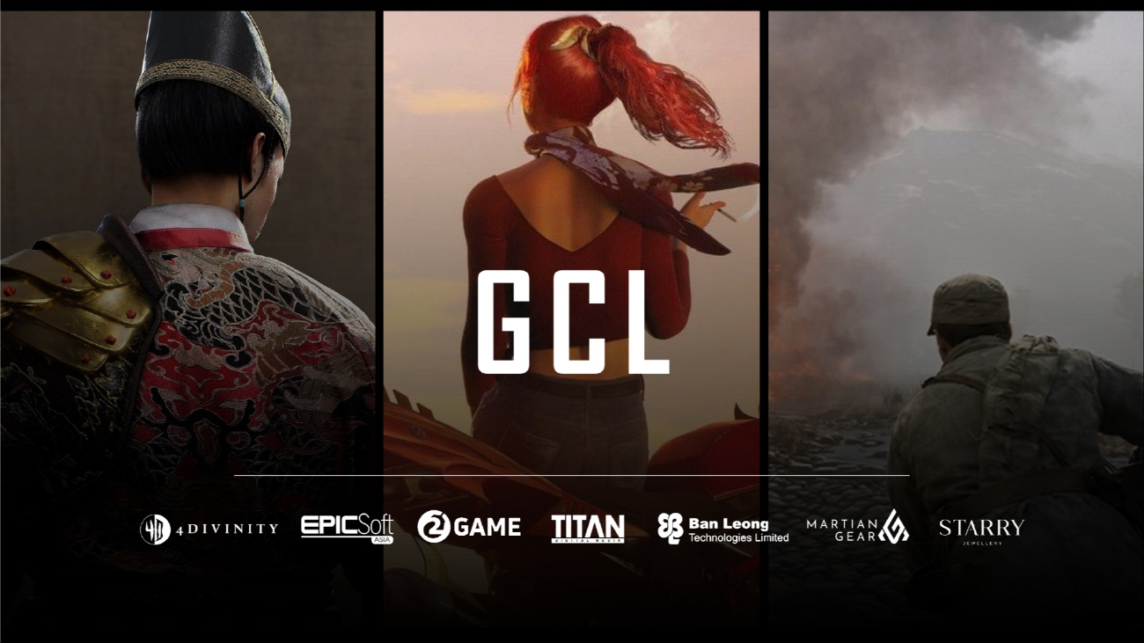
THE ASIAN POWERHOUSE IN GAMES & ENTERTAINMENT 19

